Project Design Phase-II

Data Flow Diagram & User Stories

|  |  |
| --- | --- |
| Date | 24-05-2023 |
| Team ID | NM2023TMID22553 |
| Project Name | Advanced based breast cancer with deep learning |
| Maximum Marks | 4 Marks |

**Data Flow Diagrams:**

BLOCK DIAGRAM OF BREAST CANCER

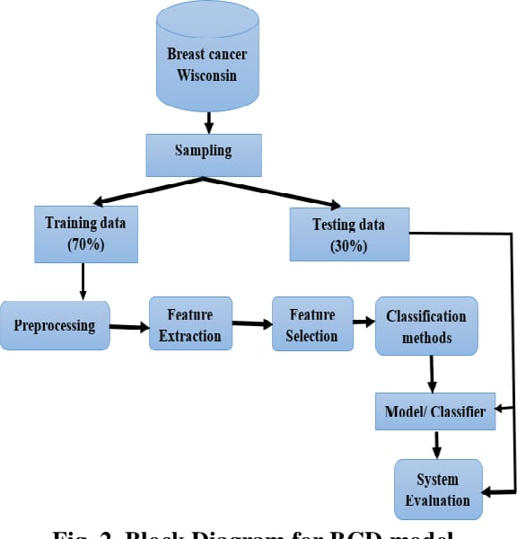

**User Stories**

Use the below template to list all the user stories for the product.

| **User Type** | **Functional Requirement (Epic)** | **User Story Number** | **User Story / Task** | **Acceptance criteria** | **Priority** | **Team Member** |
| --- | --- | --- | --- | --- | --- | --- |
| Customer (Mobile user) | Registration | USN-1 | As a user, I can register for the application by entering my email, password, and confirming my password. | I can access my account / dashboard | High | gayathri |
|  |  | USN-2 | As a user, I will receive confirmation email once I have registered for the application | I can receive confirmation email & click confirm | High | jayasuriya |
|  |  | USN-3 | As a user, I can register for the application through Facebook | I can register & access the dashboard with Facebook Login | Low | visali |
|  |  | USN-4 | As a user, I can register for the application through Gmail | I can register through gmail | Medium | alagarsamy |
|  | Login | USN-5 | As a user, I can log into the application by entering email & password | Give login using otp | High | jayasuriya |
|  | Dashboard | USn-6 | I cannot download result after image processed. | I need history option in my dashboard | high | visali |
| Customer (Web user) | login | USN-7 | As a user I login every time in browser | Give the keep me signed in option. | high | gayathri |
|  | Multiple login | USN-8 | Need multiple device login option | I need this option for download my result. | medium | alagarsamy |
|  | Doctor recommendation | USN-9 | Give doctor recommendation | Give perfect doctor | medium | jayasuriya |
| Customer Care Executive | Need importance | USN-10 | Give importance for both customer | Improve in customer care | low | visali |
| Administrator | advertisement | USN-11 | Make advertisement | Spend in advertisement | medium | Gayathri |

Breast cancer recognition is an important issue in elastography diagnostic imaging. Breast tumor biopsy has been for many years the reference procedure to assess histological definition for breast diseases. But biopsy measurement is an invasive method besides it takes larger time. So, fast and improved methods are needed. Using elastography technology, a digital image correlation technique can be used to calculate the displacement of breast tissue after it has suffered a compression force. This displacement is related to tissue stiffness, and breast cancer can be classified into benign or malignant according to that displacement. The value of compression force affects the displacement of tissue, and then affects the results of the breast cancer recognition. Finite element method was being used to simulate a model for the breast cancer as a phantom to be used in measurements and study of breast cancer diagnosis. The breast cancer using this phantom can be recognized within a short time. The proposed work succeeded in recognizing breast tumor phantom by an average correct recognition ratio CRR of about 94.25% on a simulation environment. The strain ratio SR for benign and malignant models is also computed. The results of the simulated breast tumor model was compared with real data of 10 lesion cases (6 benign and 4 malignant). The coefficient of variation CV between the simulated SR and the SR using real data reaches to about 5% for benign lesions and 4.78% for malignant lesions. The results of CRR and CV in this proposed work assure that the proposed breast cancer model using finite element modeling is a robust technique for breast tumor simulation where the behavior of real data of breast cancer can be predicted.